**Chapter 2**

**Vectors in Space**

**2.6 Quadric Surfaces**

**Section Exercises**

**For the following exercises, sketch and describe the cylindrical surface of the given equation.**

303. **[T]** 

Answer: The surface is a cylinder with the rulings parallel to the axis.

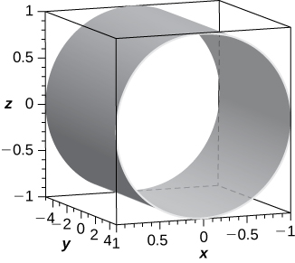

305. **[T]** 

Answer: The surface is a cylinder with rulings parallel to the axis.

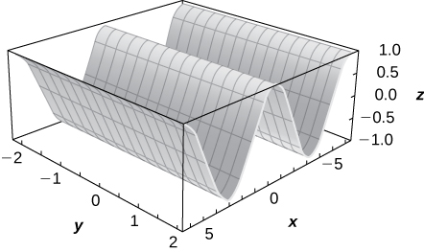

307. **[T]**

Answer: The surface is a cylinder with rulings parallel to the axis.

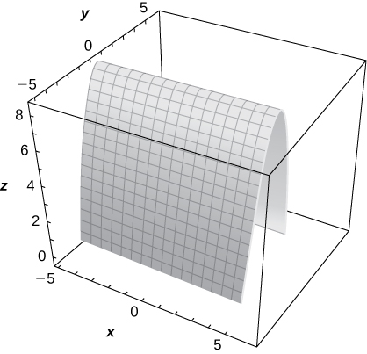

**For the following exercises, the graph of a quadric surface is given.**

1. **Specify the name of the quadric surface.**
2. **Determine the axis of symmetry of the quadric surface.**

309.

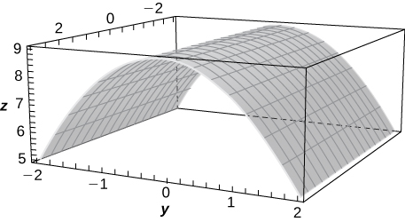

Answer: a. Cylinder; b. The axis

311.

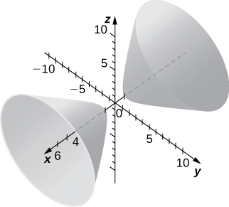

Answer: a. Hyperboloid of two sheets; b. The axis

**For the following exercises, match the given quadric surface with its corresponding equation in standard form.**

1. 
2. 
3. 
4. 
5. 
6. 

313. Hyperboloid of two sheets

Answer: b.

315. Elliptic paraboloid

Answer: d.

317. Hyperboloid of one sheet

Answer: a.

**For the following exercises, rewrite the given equation of the quadric surface in standard form. Identify the surface.**

319. 

Answer:  hyperboloid of one sheet with the axis as its axis of symmetry

321. 

Answer:  hyperboloid of two sheets with the axis as its axis of symmetry

323. 

Answer:  hyperbolic paraboloid with the axis as its axis of symmetry

325. 

Answer:  ellipsoid

327. 

Answer:  elliptic cone with the axis as its axis of symmetry

329. 

Answer:  elliptic paraboloid with the axis as its axis of symmetry

**For the following exercises, find the trace of the given quadric surface in the specified plane of coordinates and sketch it.**

331. **[T]**

Answer: Parabola 

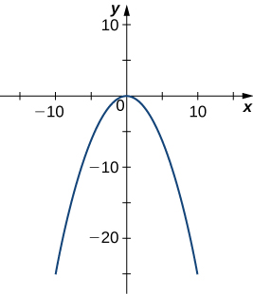

333. **[T]** 

Answer: Ellipse 

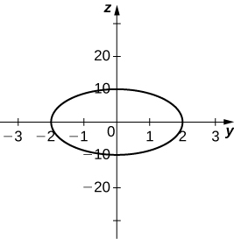

335. **[T]** 

Answer: Ellipse 

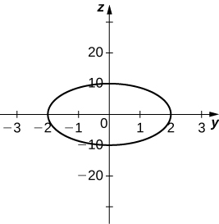

337. Use the graph of the given quadric surface to answer the questions.

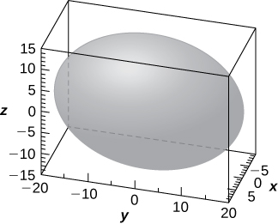

1. Specify the name of the quadric surface.
2. Which of the equations— or —corresponds to the graph?
3. Use b. to write the equation of the quadric surface in standard form.

Answer: a. Ellipsoid; b. The third equation; c. 

**For the following exercises, the equation of a quadric surface is given.**

1. **Use the method of completing the square to write the equation in standard form.**
2. **Identify the surface.**

339. 

Answer: a.  b. Cylinder centered at  with rulings parallel to the axis

341. 

Answer: a.  b. Hyperboloid of one sheet centered at  with the axis as its axis of symmetry

343. 

Answer: a.  b. Elliptic cone centered at  with the axis as its axis of symmetry

345. Write the standard form of the equation of the ellipsoid centered at the origin that passes through points  and 

Answer: 

347. Determine the intersection points of elliptic cone  with the line of symmetric equations 

Answer: and 

349. Find the equation of the quadric surface with points that are equidistant from point  and plane of equation  Identify the surface.

Answer:  elliptic paraboloid

351. If the surface of a parabolic reflector is described by equation  find the focal point of the reflector.

Answer: 

353. Show that quadric surface  reduces to two parallel planes.

355. **[T]** The intersection between cylinder  and sphere  is called a *Viviani curve*.

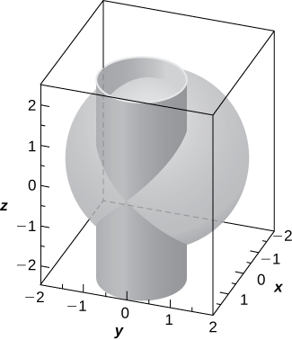

1. Solve the system consisting of the equations of the surfaces to find the equation of the intersection curve. (*Hint:* Find  and  in terms of 
2. Use a computer algebra system (CAS) to visualize the intersection curve on sphere 

Answer: a.  where 

b.

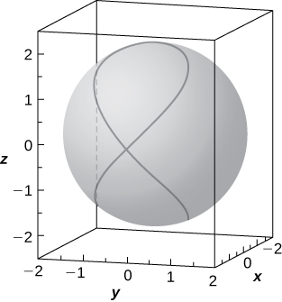

357. **[T]** Use a CAS to create the intersection between cylinder  and ellipsoid  and find the equations of the intersection curves.

Answer:

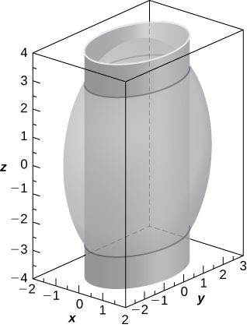

two ellipses of equations  in planes 

359. **[T]** In cartography, Earth is approximated by an oblate spheroid rather than a sphere. The radii at the equator and poles are approximately  mi and  mi, respectively.

1. Write the equation in standard form of the ellipsoid that represents the shape of Earth. Assume the center of Earth is at the origin and that the trace formed by plane  corresponds to the equator.
2. Sketch the graph.
3. Find the equation of the intersection curve of the surface with plane  that is parallel to the plane. The intersection curve is called a *parallel*.
4. Find the equation of the intersection curve of the surface with plane  that passes through the axis. The intersection curve is called a *meridian*.

Answer: a. 

b.

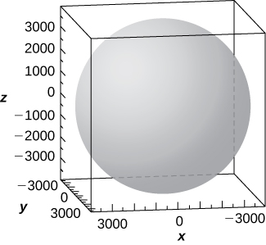

c. The intersection curve is the ellipse of equation  and the intersection is an ellipse.; d. The intersection curve is the ellipse of equation 

361. **[T]** A heart-shaped surface is given by equation 

1. Use a CAS to graph the surface that models this shape.
2. Determine and sketch the trace of the heart-shaped surface on the plane.

Answer:

a.

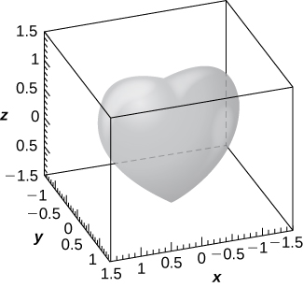

b. The intersection curve is 

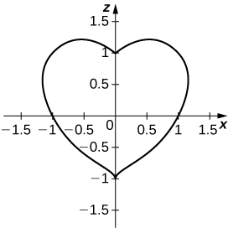

This file is copyright 2016, Rice University. All Rights Reserved.